**PROJECT 1:**

**Sporty Shoes E-Commerce website**

**Sprint Plan:** No of Sprint-3, Duration-21days.

Sprint 1: Prepare a flow chart of the application and core concept, algorithm. Prepare separate git repository and update each and every work.

Sprint 2: Create prototype application (Wire frame)

Sprint 3: Verify/Test application functionalities and Update it in git.

**Flow of the Application:**

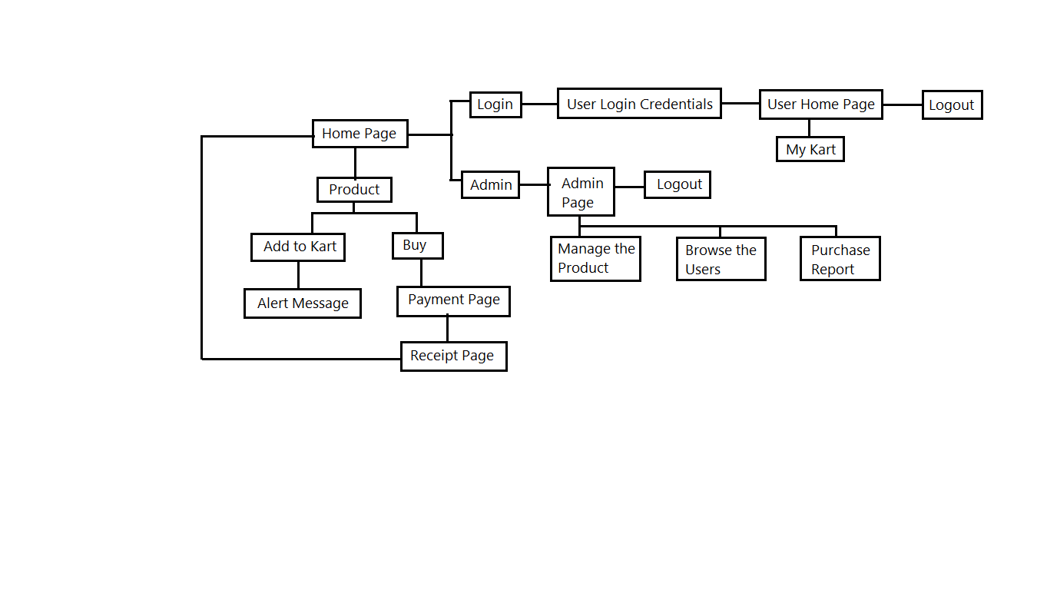

**Algorithm:**

1. Run the Application in eclipse.
2. Home page will be displayed. In home page we have two login options Login as User and Login as Admin. We can able to buy a product without login but can’t able to add it into the kart.
3. Login as User by clicking login option. After login you can see your username will be display in navbar and also have My kart option and you can able to logout from your account
4. As a User you can able to buy any product and add it to your kart and can able to see what are the items you are added in your kart.
5. In Payment gateway you need to enter dummy details then get a success page after submission.
6. If Login as Admin you have an option to Manage the products (Add, Delete, Update, View) see the User details and able to see the purchase list.
7. In User detail page we can see all user details and can able to filter out needed person by name.
8. In purchase list we can able to see how many people purchase the product and its details with time.

**Instruction for work on Application:**

**Without login:**

* You can see the product and able to select it (Listed in Men’s shoe section) and view the particular product detailly.
* You can able to buy the product but can’t able to add it to kart (need to login)
* After click on buy button, it will show enter your card details after submit it success page will be display and have an option to redirect to home again.

**Login as User:**

* In Home page we have a two-login options Login and Admin.
* Login option is for users and Admin option is for Admin.
* Click on Login option the sign in page will be displayed. Enter valid credentials to login to your page.
* If new to website, then there is an option for new user. By click on this to create a new account
* As a user we can able to buy a product and able to add it into our kart. We can able to see the product in kart. If click on the product it will directly redirect to the particular product page.
* Logout option is for leave from the page.

**Login as Admin:**

* In Home page just click on the Admin option to redirect to admin sign in page. Here sign in with valid credentials
* After login to admin home page there are three options will be displayed
  + Manage the Products
  + Browse the Users
  + See the Purchase report
* In Manage project option we can able to Add a new product into the site and similarly delete, update and view the products.
* In Browse user option we can able to see all users who have an account in this website.
* In Purchase report option we can see the users purchase report with date and able to filter out.

**Login Credentials:**

* **User Logins:**

User id: Admin

Password: 123

* **Admin Logins:**

User id: Admin

Password: 123

* **Database connection:**

AWS RDB is connected.

* **Framework Used:**

Spring MVC is used.